**WIP DRAFT – Probably more spelling and grammar errors in here than there are people on the earth**

**Introduction**

Wowza, so you’re using the Sorter for the first time and don’t know how! What a pickle you’re in. Well don’t worry, your manager or some other person has just passed you this packet and told you to learn, and learn you will. This packet lays out a step by step guide on how to go through the entire sorter process from start-up to the second pass. There are even pictures for you! And by the end of this, you’ll be just as snarky and sarcastic as I am. Oh, and I guess you’ll know how to use the sorter as well.

**Section 1 – Start Import/Export Process**

This process will load any changes made in OCVR into the sorter, things like signature changes, voter status, etc. Do this before anything else so the sorter system is completely up to date. This process can be done on any computer in the elections office, not just the one at the sorter.

1. Make sure the Server and the Workstation Computer are powered on. If they aren’t on, then get the assistance of the manager. If they are not available, curl in a ball on the ground and wait for rescue.
   1. There should be a power button on the touch screen monitor. If you tap this and it does not come on, the work station is most likely off. Call a manager or other staff for further assistance.
2. Turn on screen and open the web browser.
3. If not already open, then go to <https://sorter/login> using the browser’s search bar.
   1. If presented with a warning, then select “Advanced” and “Continue to site (Unsafe).” It’s safe, trust me.

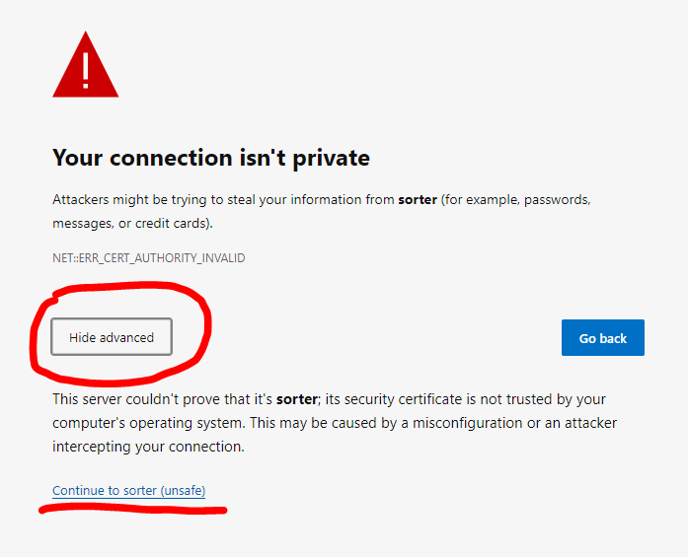

1. Log in using your credentials.

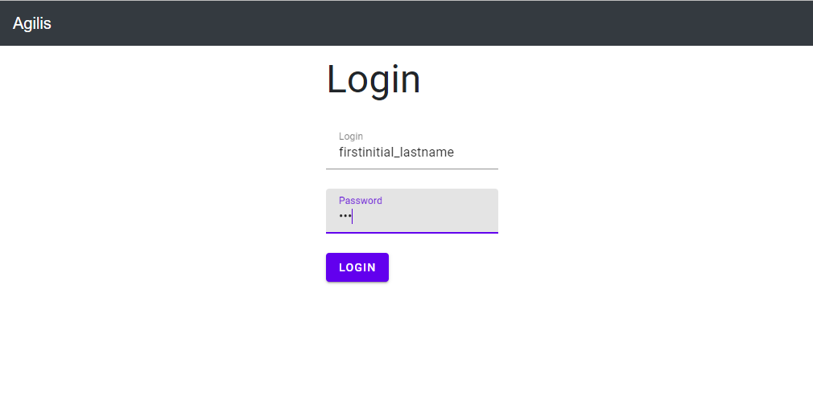

1. Select the correct election from the drop down in the top right.

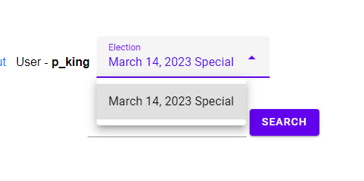

1. On the link bar, select “Import/Export.”



1. In the Import/Export menu, select full import.

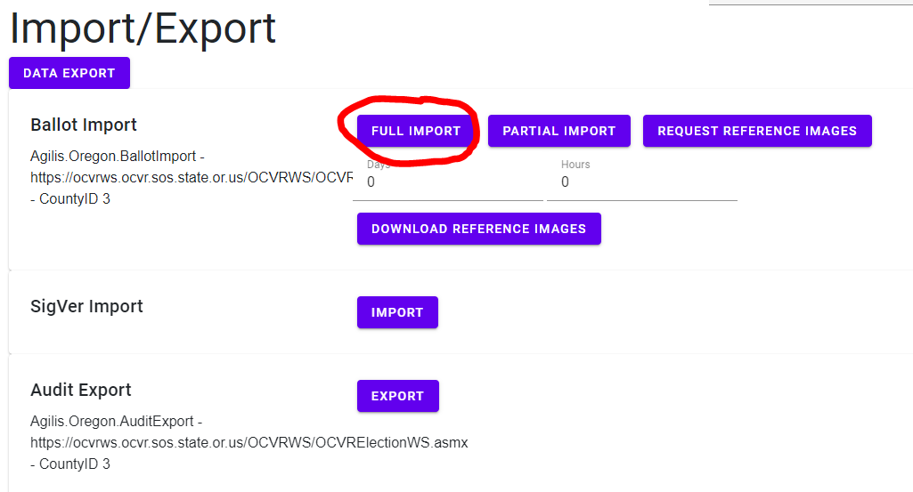

* 1. Now grab a cup of coffee and wait, it’s going to be a second.

1. Once Finished, select “Accept Import” 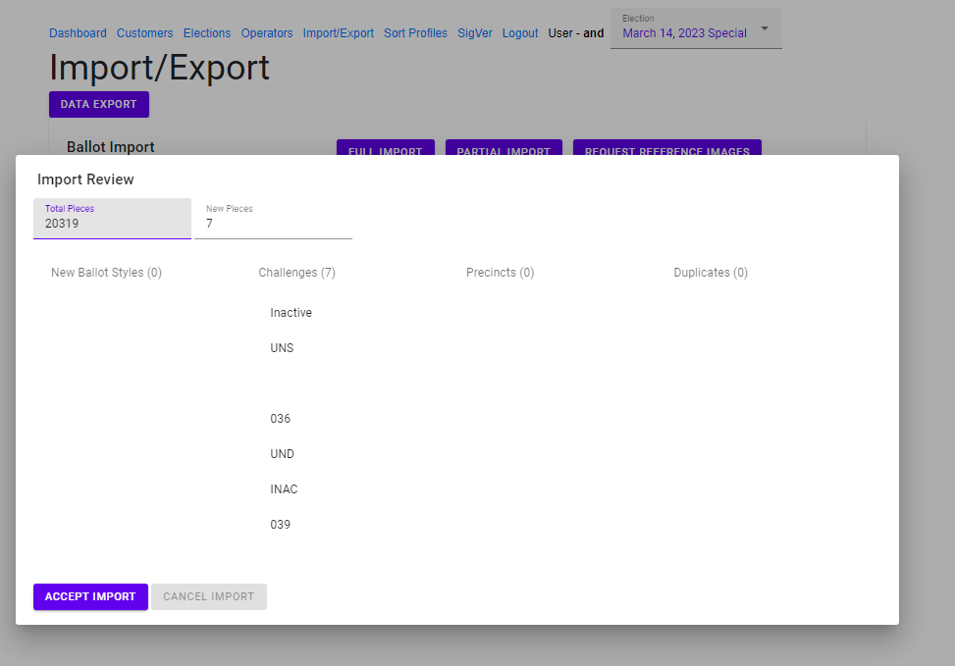
2. When all the scanning is complete, you can now **Export the data back into OCVR**. To do that, simply select the “Export Button” at the bottom of the Import/Export menu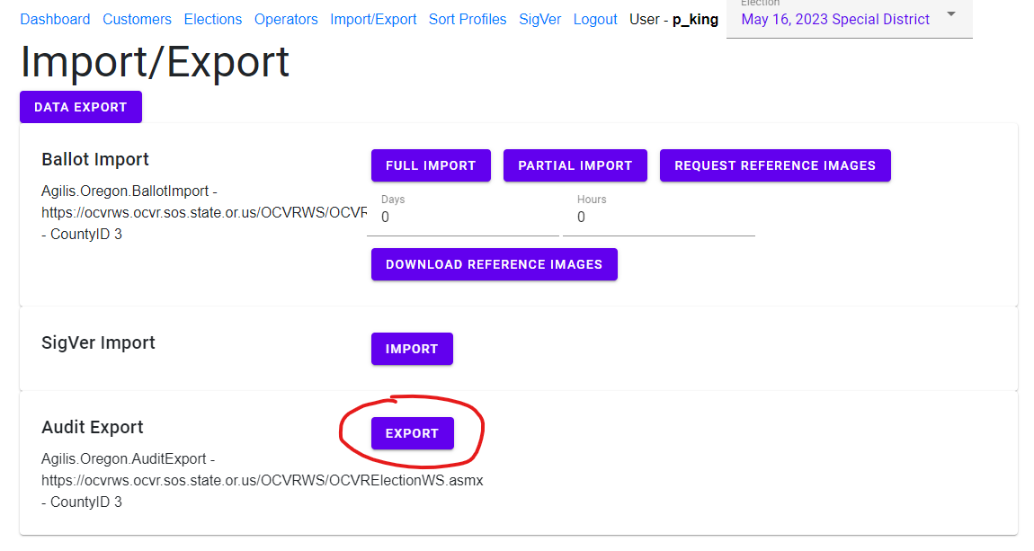

**Section 2 – Sorter Power Up/Down Process**

You can’t do much with the sorter without it being on. These steps will walk you through how to turn on or off the sorter when needed.

1. 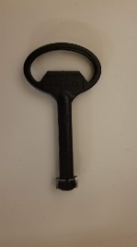Locate the panel on the left side of the machine, closest to the side facing the feeder.
   1. Open the panel using the service key.🡪
2. In the top right area inside, there are four white switches on a silver box labeled “Main,” “Motors,” “Outlets,” and “Aux.”
   1. Power Up/Down the machine  
      To power up the machine, flip the following switches in sequence: “Main,” “Motors.” “Outlets,” and “Aux.”

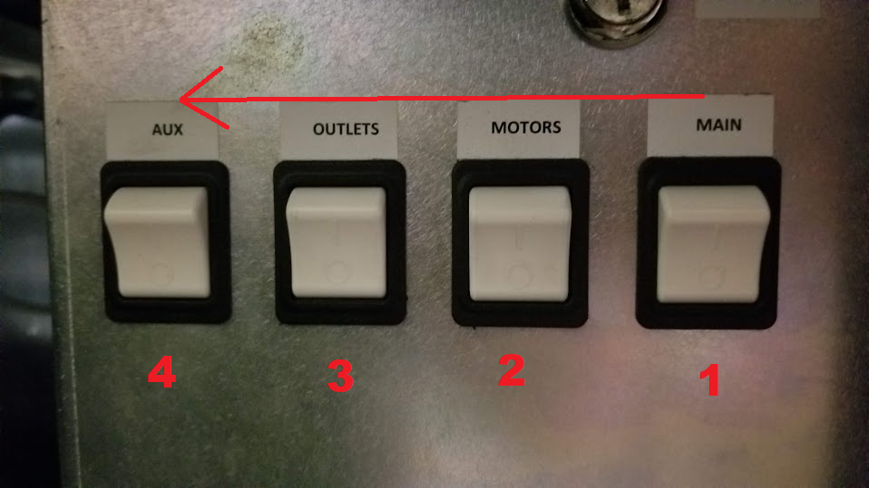

* 1. To power down the machine, flip the following switches in sequence: “Aux”, “Outlets”, “Motors”, and “Main”. (The power up sequence in reverse)

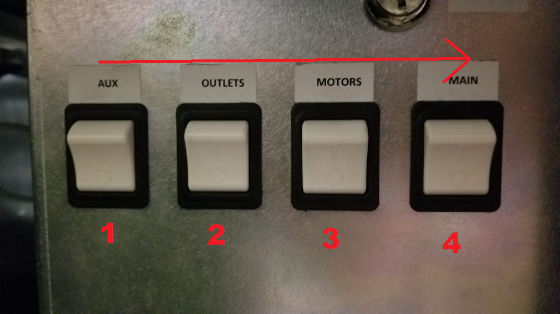

Failing to follow this procedure will… probably blow it up or something, I don’t know I’ve never tried it.   
  
You should now be hearing the machine power up and you will be ready to start sorting.

**Section 3 – Start Scanning and Sorting**

Now for the best part of the sorter—actually scanning and sorting. These steps will show you how to do the first, second, and challenge sorting processes or “Passes”. Now you may be wondering, what is a pass and why should I care. Well if you don’t care then the exit is right behind you. A pass is just a way to refer to the process of sorting, scanning through every ballot that comes in through the mail or from ballot boxes. What counts as a finished pass depends on which pass you’re one.

**The First Pass** is about getting the initial count and signatures in the sorter for signature verification, once all the ballots have been scanned in and any rejects have been dealt with, the pass is finished. For more information on how to resolve any rejects, refer to section 4.

Once verified, the remaining ballots will go through a **Second Pass** to count the number of verified ballots before being sent to the ballot processing tables.

**The Challenge Sort** just sorts ballots that have potential issues, like another person signed or there is just not signature to begin with or who know what else they’ve thought of.

Only perform the following if the sorter is powered up and the Import process has been completed!

1. On the desktop of the Client Machine, open the Helm.
   1. The icon should be that of a ships sailing wheel.
   2. You can tell the difference between workstation and server by looking at the top right corner of the computer’s wallpaper.
2. On all of these, set the Mail Source to where ever the ballots have come from, this can be from Mail, Drop Sites, or the Front Counter.

**Section 3a – First Pass**

1. In the helm, select the Scan Option.
2. Select the date to ensure that it’s correct day.
3. Select “Scan – First Pass.”
4. Select “Double Detect” and “Piece Printing.”
   1. Double Detect will tell the sorter to find if two ballots have gone in at the same time
   2. Piece printing will print a date and time on the ballot

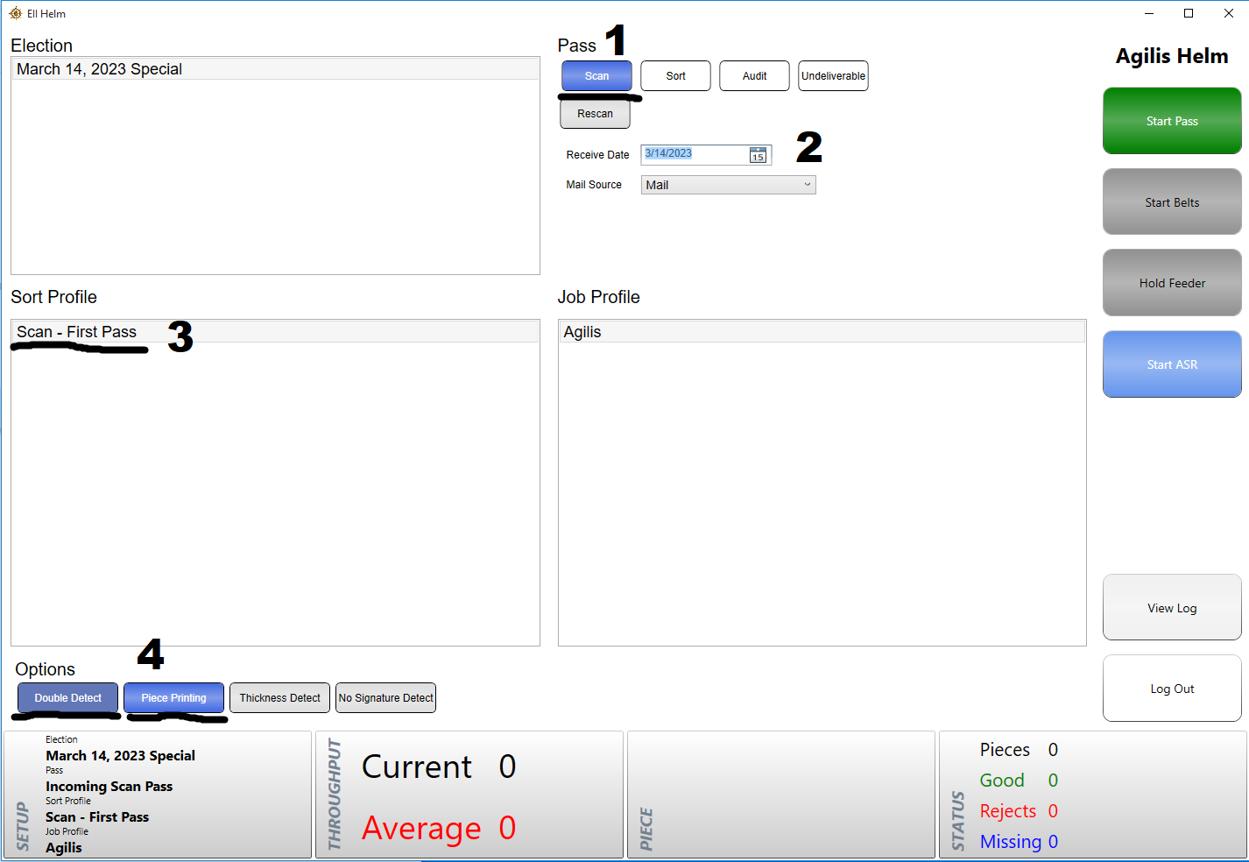

**Section 3b – Second Pass**

**Only select these options if you have finished the first pass and Signature Verification (SigVer) is completed**. If you preform the second pass before SigVer has been completed it will erase the ballot status from SigVer and we will all be mildly upset at you. For more information about Signature Verification, refer to section 5.

1. In the helm, select Audit Option.
2. Select “Audit – Second Pass.”
3. Select “Double Detect” but NOT “Piece Printing”
4. In the Console, insure that there are a number of ballots ready to sort

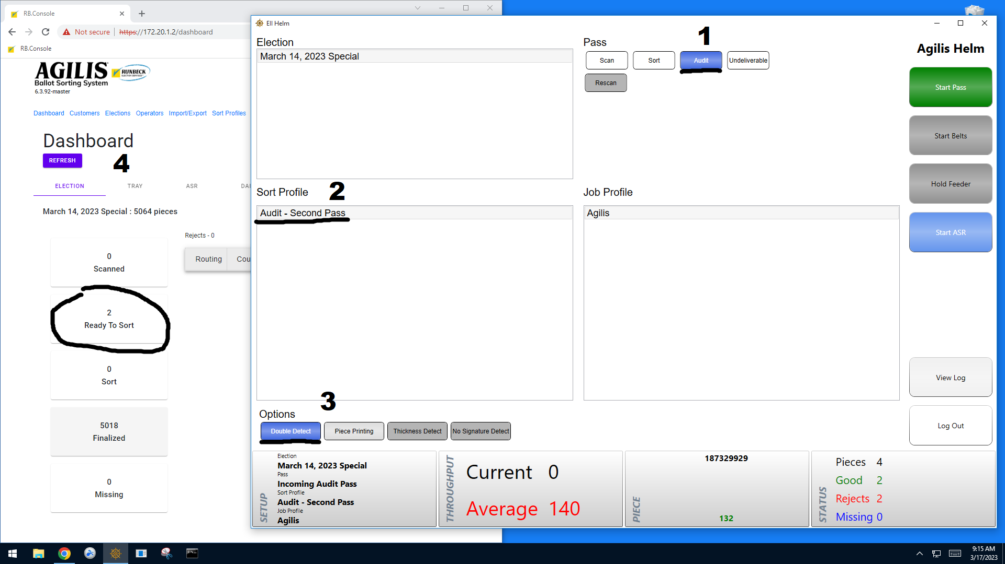

**Section 3c – Start Belts**

1. Press the large green button labeled “Start Pass.”
   1. There will also be checkmarks on the screen that will go from blue to green. Once all the checkmarks are green, continue to the next step.
   2. You should now hear the machine beep a few times before hearing the belts begin to run.
2. The button labeled “Start Belts,” located under “Start Pass,” should have changed from grey to red. Press that button to get them doggies rollin’!
3. Press the button labeled “Release Feeder,” located under “Start Belts,” labeled, “Release Feeder.” This will start the feeder in front of you.
4. Insert the ballots into the machine. This can be done by hand or using the metal slider to keep the ballots standing upright. The machine will automatically pull the ballots inside when force is applied to the red belt on the right end of the feeder.
   1. As you feed in ballots, you should see them run through the machine and then automatically sort into the trays. If you look at the “Status” tab, you can see what each of these trays signify. Typically, the ballots for the first and second passes are sorted into the following trays:
      1. Tray 1 – Damaged or Unreadable(Reject)
      2. Tray 2 – Challenge Ballots
      3. Tray 3-7 – Accepted Ballots
      4. Tray 8 – Overflow

For a Challenge Sort, the trays will be as follows:

1. Tray 1 – No signature
2. Tray 2 – Bad Signature
3. Tray 3 – Under Review (will be checked manually)
   1. With a small amount of ballots, you can use your hand to push on the ballots as they feed in; however, with a larger amount, it’s best to stack them all on before releasing the feeder, and then continuing to fill the stack as it feeds in.
   2. You can start and stop the feeder as many times as you want without affecting the process.
   3. While it is not extremely dangerous to use your hands to feed ballots in, do be careful not to get your hand fed in as well, or the machine might get a taste for human flesh.
   4. If you run into any errors, such as ballots with damaged barcodes, refer to section 4.
4. Once all the ballots have been fed through, you can stop the belts by pressing the “Hold Belts” button.
5. Tap on the “Status” tab and tap “Close and Clear all pockets.”
   1. The label printer at the end of the machine should print out labels for all the trays of ballots.
   2. Once finished printing, you or your lackey should put them into the medium sized trays to get ready for the second pass.
6. Once all the pockets have been cleared and empty, press “End Pass.”
   1. You should now hear some more concerning scraping sounds, and the green checks should switch the blue.
7. You should now move on to signature verification, which will not be covered in this manual.

**Section 4 –Scan Errors**

1. *Damaged Barcodes* – Sometimes, the barcode just might not have read properly and may work if the ballot is sent through again. However, if it is still unsuccessful when trying again or is clearly damaged or obstructed, follow the steps below to print out a new barcode.
   1. On the desktop of the workstation, locate the “Print Barcode” application.
   2. Open it and either type in the ballot number or attempt the use the scanner to scan the barcode.
      1. Sometimes, the sorter might not be able to properly read the barcode as it goes through, but the scanner has a better time at reading the barcode because the scanner cares a little more about getting this done than the sorter.
   3. Press Enter. The label printer behind the screen should spit out a sticker with the voter’s name and new barcode.
   4. Place the sticker over the old barcode but do not cover the name, ballot number, or any other information if you can, just the old barcode.
   5. If the sorter still rejects the ballot, then there is most likely something else wrong with it, such as not Active or there is something wrong with the voter’s registration.
2. *Ballot Jam* – Sometimes, ballots can get jammed, stopping the whole process and are generally somewhat annoying. When the machine detects a jam, it should automatically stop the belts. On rare occasions, the belts won’t stop, meaning you’ll have to quickly stop the belts before the situation gets worse. To resolve the issue, follow these steps.
   1. Get the ballot unstuck, wherever it is, without ripping it if possible.
      1. If the jam is on the lines to the tray, attempt to wiggle it free from the belts or rubber. Don’t try to force it out or you’ll risk tearing it.
      2. If the jam is inside of the machine (as in behind the Plexiglas), access the inside of the machine by lifting either of the glass’ side panels. Carefully remove the jammed ballot(s) from wherever they decided to set up shop.
   2. Once you’ve removed the jam, start the belts again and let any remaining ballots in the tracks go through. They should automatically go to a tray or to overflow if they haven’t been processed by the machine yet.
   3. After the tracks have been cleared, take any overflow ballots – as these have not been fully processed yet – and run them with the rest of the other unprocessed ballots.
   4. Occasionally, the rails that the tray holders run on become scratched and rough, which will cause the rails get stuck in place and cause a jam. If you are frequently running into jams, consider sanding down the rails using sand paper.
3. *Camera Error* – Sometimes the camera will fail to start when the rest of the sorter does, because of course it does. If this happens and you run ballots through the sorter, it will reject them all with the message “Camera Unavailable”. To resolve this issue, follow these steps:
   1. On the desktop, locate the batch file titled, “restart camera service” (command console icon).
   2. Open the program and it should start the camera process.
      1. You can actually see the camera inside of the machine through the Plexiglas. If it successfully restarted, you should see the light on it go from blue to green and two blinking lights begin to blink off and on.
   3. If this does not work, attempt to start the service again; it may take more than one time.
   4. If anything was rejected, simply run them through again.
4. Rejected Ballot – Ballots can be rejected for many reasons and typically they are easy to resolve. On the next page is a table of rejection reasons and how to fix them:

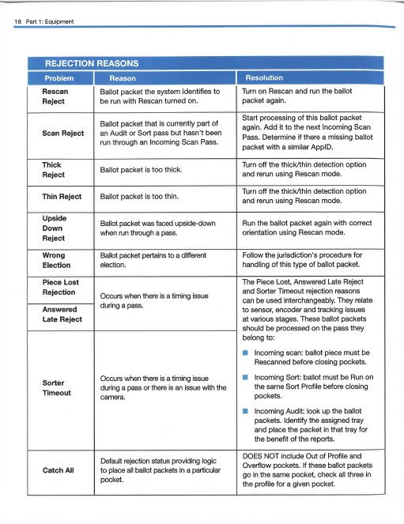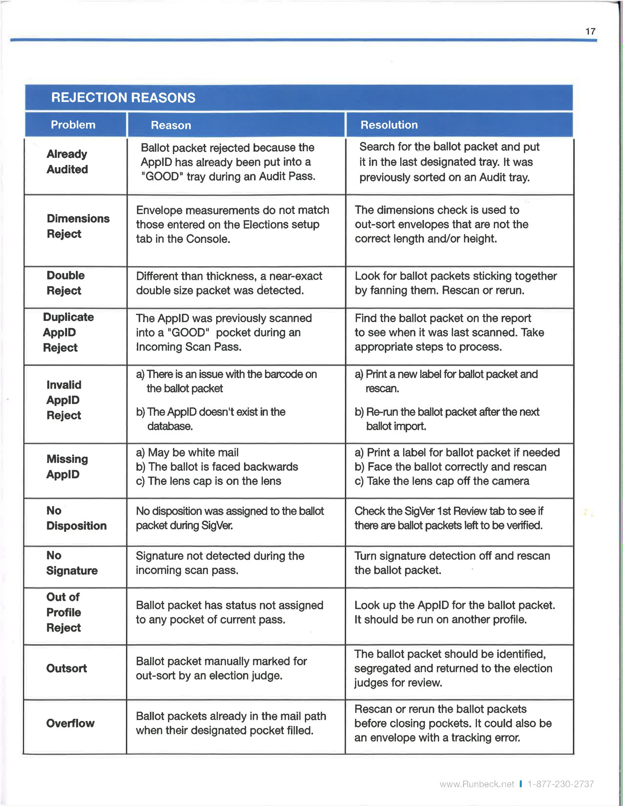

Should all attempts to solve these errors fail, or there is an error that is not covered in this section, contact a manager or permanent employee and pray to the sorter gods.

[List Runbeck contacts here]

**Section 5 – SigVer and ASR**

This manual focuses on just the sorter system, so we won’t go in depth about SigVer here. For an in depth read on signature verification, please refer to *SigVer and You: How to get in touch with your inner Signature.* The basic function of signature verification is to go over all of the

**Section 6 - If all else fails, RTFM!**

If my wonderful walk through here wasn’t good enough for you, or there was some other situation that my infinite wisdom didn’t see coming, then it’s time to delve into the manual. The manual *should* located on the shelf directly to the left of the sorter sitting on top.