**WIP DRAFT – Probably more spelling and grammar errors in here than there are people on the earth**

**Introduction**

Wowza, so you’re using the Sort for the first time, but don’t know how! What a pickle you’re in. Well don’t worry, your manager or some other person has just passed you this packet and told you learn, and learn you will. This packet lays out a step by step guide on how to go through the entire sorter process from Start up to the second pass. There are even pictures for you! And by the end of this, you’ll be just as snarky and sarcastic as I am. Oh, and I guess you’ll know how to use the sorter as well.

**Section 1 – Start Import/Export Process**

This process will load any changes made in OCVR into the sorter, things like signature changes, voter status, etc. It’s recommended that you do this before anything else so the sorter system is completely up to date. This process can be done on any computer in the elections office, not just the one at the sorter.

1. Make sure Server and Workstation Computer are powered on, if they aren’t get the assistance of the manager. If they are not available, curl in a ball on the ground and wait for rescue.
   1. There should be a power button on the touch screen monitor, if you tap this and it does not come on, the work station is most likely off. Call a manager or other staff for further assistance.
2. Turn on screen and open the web browser.
3. If not already open, go to <https://sorter/login> using the search bar
   1. If promoted with a warning, select “Advanced” and “Continue to site (Unsafe)” It’s safe, trust me.

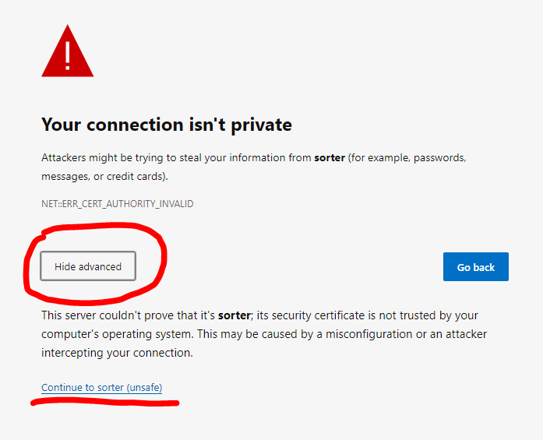

1. Login using your credentials.

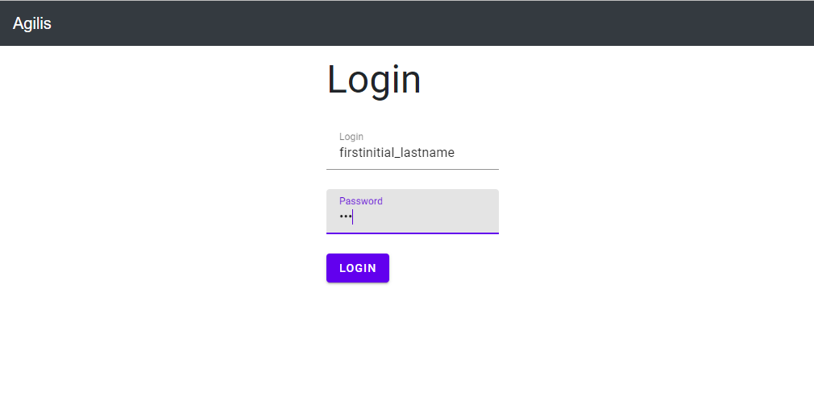

1. Select the correct election from the drop down in the top right

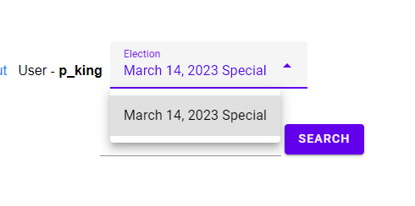

1. On the stop bar of links, select “Import/Export”



1. In the Import/Export menu, select full import

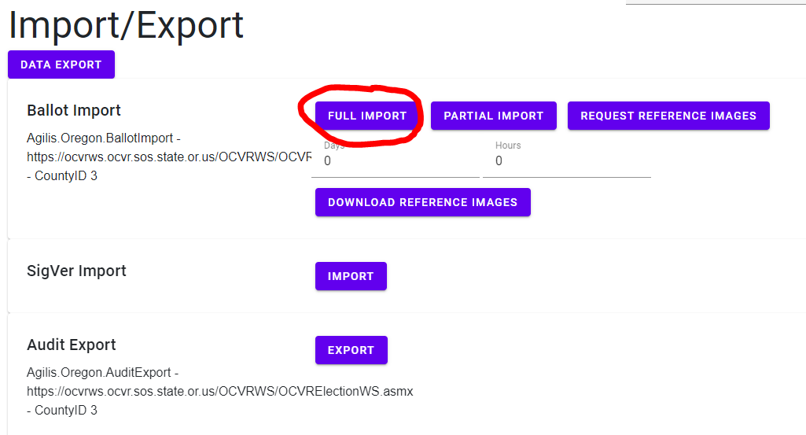

* 1. Now grab a cup of coffee and wait, it’s going to be a second

**Section 2 – Sorter Power Up/Down Process**

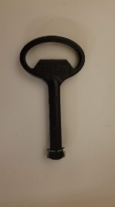You can’t do much with the sorter without it being on. These steps will walk you through how to turn on or off the sorter when needed.

1. Locate the panel on the left side of the machine, closest to the side facing feeder.
   1. Open the panel using the service key 🡪
2. In the top right area inside, there are four white switches on a silver box labeled “Main”, “Motors”, “Outlets”, and “Aux”.
3. Power Up/Down the machine

To power up the machine, flip the following switches in sequence: “Main”, “Motors”, “Outlets”, and “Aux”.

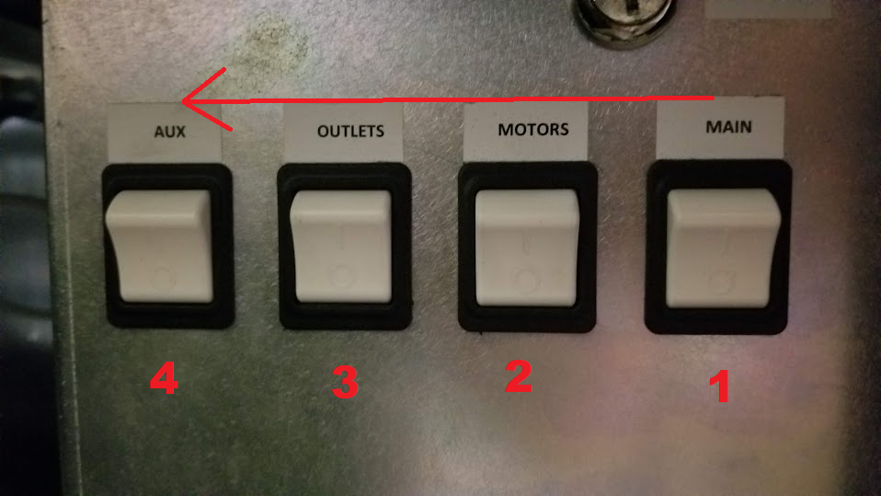

To power down the machine, flip the following switches in sequence: “Aux”, “Outlets”, “Motors”, and “Main”. (The power up sequence in reverse)

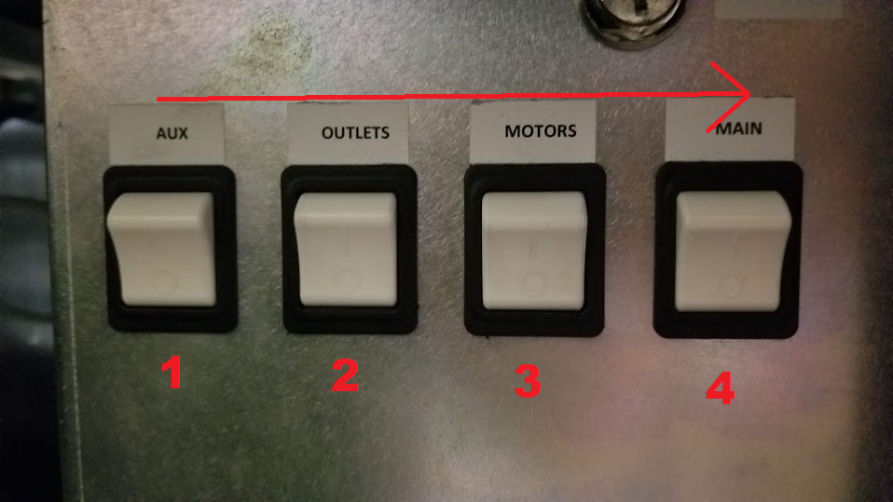

Failing to follow this procedure will, probably blow it up or something I don’t know I’ve never tried it.

1. You should now be hearing the machine power up and you will be ready to start sorting.

**Section 3 – Start Scanning and Sorting**

Now for the best part of the sorter, actually scanning and sorting. These steps will show you how to do the first, second and challenge sorting processes. The First Scan is about getting the initial count and signatures in the sorter to be verified. Once verified, the remaining ballots will go through a second scan to count how many verified ballots are there and then sent to the table to be sorted. The Challenge sort just sorts ballots that have potential issues, like another person signed or there is just not signature to begin with or who know what else they’ve thought of.

Only preform this if the sorter is powered up and the Import process has been completed

1. On the desktop of the Client Machine, open the Helm
   1. The icon should be that of a ships sailing wheel
   2. You can tell the difference between workstation and server by looking at the top right corner of the computers wallpaper
2. Select the correct election before starting in the “Election” Section.

**Section 3a – First Pass**

1. In the helm select the Scan Option
2. Select the date to ensure that it’s correct day
3. Select “Scan – First Pass”
4. Select “Double Detect” and “Piece Printing”

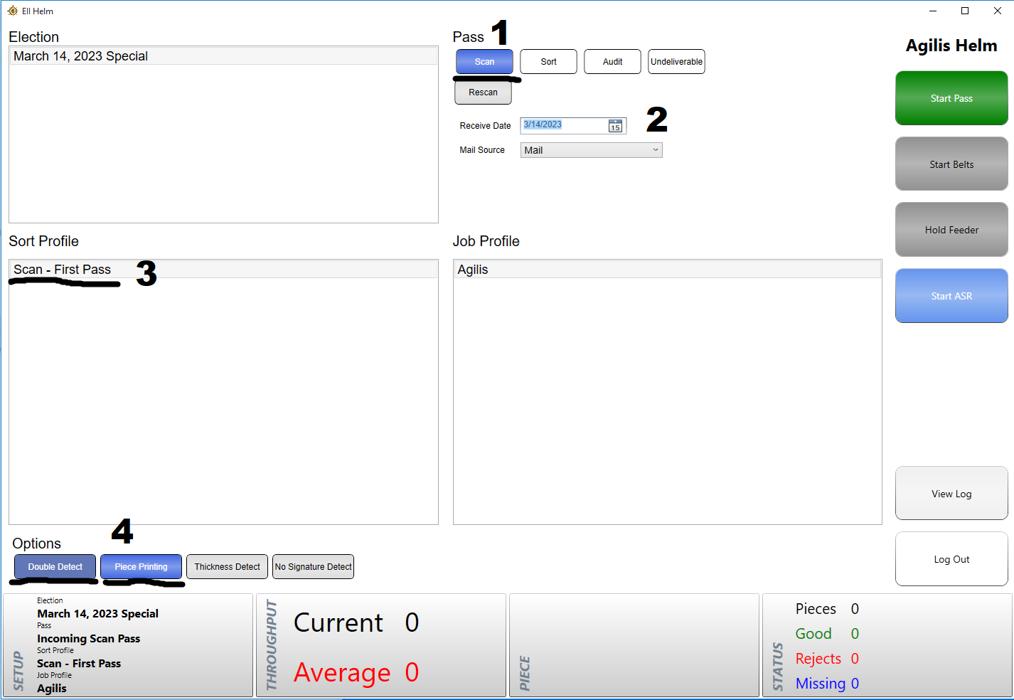

**Section 3b – Second Pass**

Only select these options if you have finished the first pass

1. In the helm, select Audit Option
2. Select “Audit – Second Pass”
3. Select “Double Detect” But NOT “Piece Printing” like before
4. In the Sorter Dashboard you should be able to see that there are ballots “Ready to sort” in the “Elections Tab”

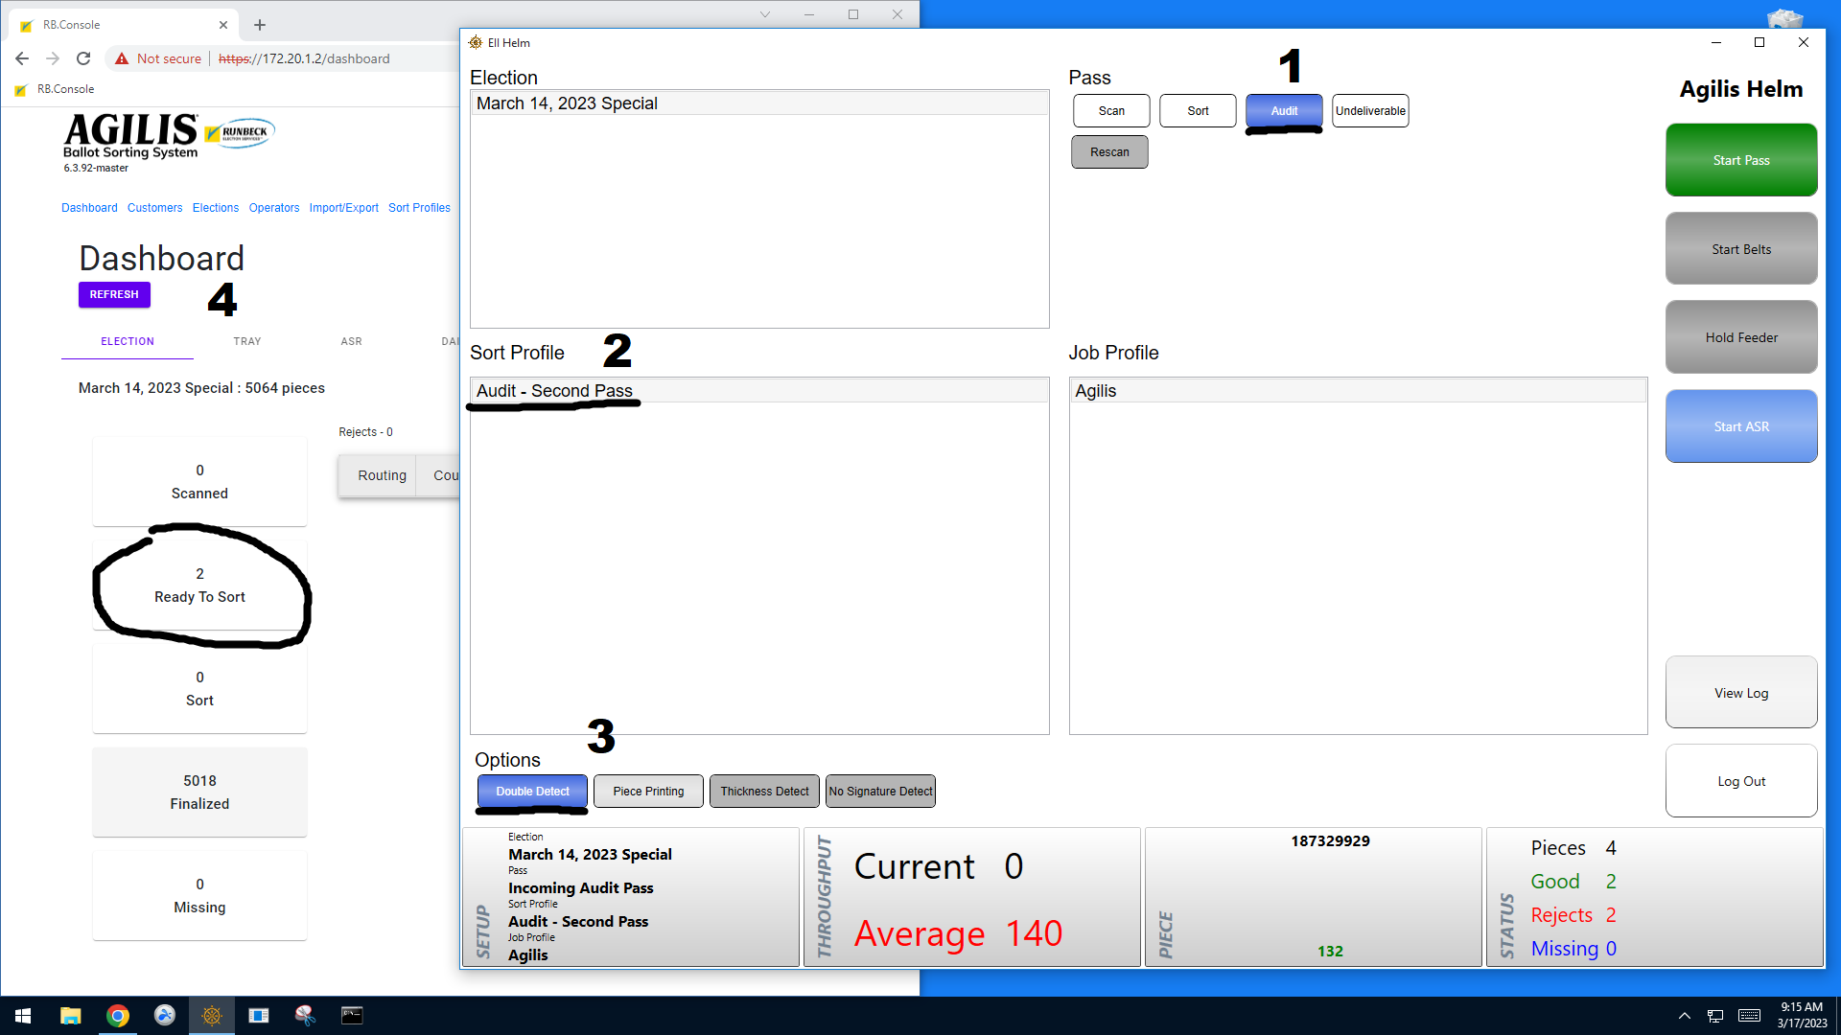

**Section 3c – Start Belts**

1. Press the large green button labeled “Start Pass”
   1. Once started, you should here some unsettling noises as the machine powers up, don’t worry it’s probably fine.
   2. There will also be check marks on the screen, which will go from blue to green. Once all the checks are green continue to the next step
   3. You should now here the machine beep a few times before hearing the belts begin to run
2. The Button under “Start Pass”, labeled “Start Belts”, should have turned from grey to red. Press that button to, get them doggies rollin’!
3. Press the button under the “Start Belts”, labeled, “Release Feeder”, this will start the feeder in front of you.
4. Insert the ballots into the machine, this can be done by hand or using the metal slider to keep the ballots standing upright. The machine will automatically pull the ballots inside when force is applied to the red belt on the right end of the feeder.
   1. As you feed in ballots you should see them run through the machine and then automatically sort into the trays. If you look at the “Status” Tab, you can see what each of these trays signify. Typically the ballots for the first and second scan are sorted into the following trays:
      1. Tray 1 – Damaged or Unreadable
      2. Tray 2 – Challenge Ballots
      3. Tray 3-7 – Accepted Ballots
      4. Tray 8 – Overflow

For a Challenge Sort the trays will be as follows:

1. Tray 1 – No signature
2. Tray 2 – Bad Signature
3. Tray 3 – Under Review (Will be checked Manually
   1. With a small amount of ballots, you can use your hand to push on the ballots as the feed in, however with a larger amount, it’s better to stack them all on before releasing the feeder, and then containing the fill the stack as it feeds in.
   2. You can start and stop the feeder as many times as you want without effecting the process
   3. While it is not extremely dangerous to use your hands to feed ballots in, do be careful not to get your hand fed in as well, or the machine might get a taste for human flesh.
   4. If you run into any errors, such as ballots with damaged barcodes, refer to section 4.
4. Once all the ballots have been fed through, you can stop the belts by pressing the “Hold Belts” button.
5. Tap on the “Status” tab and tap “Close and Clear all pockets”.
   1. You should see the label printer at the end of the machine print out labels for all the trays of ballots
   2. Once finished printing, you or your lackey should put them into the medium sized trays to get ready for the second pass.
6. Once all the pockets have been cleared and empty, press “End Pass”
   1. You should now here some more concerning scraping sounds, and the green checks should switch the blue.
7. You should now move on to signature verification, which will not be covered in this manual.

**Section 4 –Scan Errors**

1. Damaged Barcodes – Sometimes the barcode just might not have been read properly and may work if the ballot is just sent through a second time. However, if it is still unsuccessful or is clearly damaged or obstructed, follow the steps below to print out a new barcode.
   1. On the desktop of the workstation, locate the “Print Barcode” application
   2. Open it and either type the ballot number or attempt the use the scanner to scan the barcode
      1. Sometime the sorter might not be able to properly read the barcode as it goes through, but the scanner has a better time at reading the barcode than the scanner is, because the scanner cares a little more about getting this done than the scanner.
   3. Press enter and the label printer behind the screen should spit out a sticker with the voters name and new barcode.
   4. Place the sticker over the old barcode but do not cover the name, ballot number or any other in formation if you can, just the old barcode.
   5. If the sorter still rejects the ballot there is most likely something else wrong with it, like it’s been inactivated or there is something wrong with the registration
2. Ballot Jam – Sometime ballots can get jammed which stops the whole process and is generally somewhat annoying. When the machine detects a jam it should automatically stop the belts, however on rare occasions it won’t, meaning you’ll have to quickly stop the belts before the situation gets worse. To resolve the issue, follow these steps.
   1. Get the ballot unstuck, wherever it is. Without ripping it if you can.
      1. If the jam is on the lines to the try, attempt to wiggle it free from the belts or rubber. Don’t try to force it out or you’ll risk willing it.
      2. If the jam is inside of the machine (as in behind the Plexiglas), access the inside of the machine by lifting either of the glass side panels. Then carefully remove the jammed ballot(s) from wherever they decided to setup shop.
   2. Once you’ve removed the Jam, start the belts again and let any remaining ballots in the tracks go through. They should automatically go to a tray, or to overflow if they haven’t been processed by the machine yet. Take any overflow ballots and run them again as these have not been fully processed yet.
   3. After the tracks have been cleared, take the ballots from the overflow tray and feed them through again with the rest of the other unprocessed ballots.
   4. Occasionally, the rails that the tray holders run on can get become scratched and rough, which will cause it get stuck in place and cause a jam. If you are commonly running into jams, it may be adventitious to sand down the rails using sand paper.
3. Camera Error – Sometimes the camera will fail to start when the rest of the sorter does, because of course it does. If this happens and you run through ballots, the sort will reject them all with the message “Camera Unavailable”. To resolve this issue follow these steps:
   1. On the desktop, locate the batch file titled, restart camera service (It should have the icon of a command console)
   2. Open the program and it should start the camera process
      1. You can actually see the camera inside of the machine through the glass, it if successfully restarted, you should see the light on it go from blue to green and two blinking lights begin to blink off and on.
   3. If this does not work, attempt to start the service again, it may take more than one time.
   4. If anything was rejected, simply run them again
4. Ballot Rejects – There are many reasons that the sorter could reject a ballots without having anything obviously wrong with it. When a ballot is rejected, in the Pieces tab its ballot number will show up in red text with an explanation of the reason for reject. Below is a list of the errors and steps on how to resolve.

Should all attempts to solve these errors fail, or there is an error that is not covered in this section, contact a manager or permanent employee and pray to the sorter gods.

[List Runbeck contacts here]